**MYTHIC**

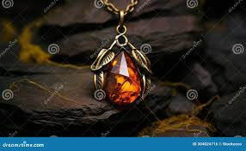

**Name:** Multi Shade Amethyst

**Brand:**  Harry Winston

**Model#:** 002

**Color:** Multi

**Price: $4000**